A Hybrid Quantum-Classical Genetic Algorithm for Climate-Resilient Crop Breeding in Indian Agriculture
Abhinav Renjith¹ Shubham Bhuyan² Aayush Ojha³ Dr. S. Sandosh^{4*}
abhinav.renjith2023@vitstudent.ac.in, shubham.bhuyan2023@vitstudent.ac.in, aayush.ojha2023@vitstudent.ac.in, sandosh.s@vit.ac.in
^{1,2,3} Students ⁴Assistant Professor Senior, Vellore Institute of Technology, Chennai, India
Abstract. Climate change is a serious threat to the world's food security, which means that resilient crop varieties must be developed quickly. Because they are slow and computationally demanding, traditional plant breeding techniques are unable to keep up with the rising frequency of severe weather conditions. In order to speed up the process of finding high-yield, climate-resistant crop breeds, this study aims to address the need for an effective crop breeding optimal system. These challenges are addressed by the suggested Hybrid Quantum-Classical Genetic Algorithm (HQGA) framework, which makes use of the special powers of quantum computing and uses quantum rotation gates to control the search for the most optimal gene combinations. This system bridges the gap between traditional farming techniques and the demands of a changing climate by improving the efficiency and speed of the breeding process through an integrated approach of quantum genetic operations and quantum Monte Carlo simulations for fitness evaluation.

Keywords: Hybrid Quantum-Classical Genetic Algorithms, Machine Learning, Climate resistant Crops, Quantum Rotation Gates, Quantum Monte Carlo

Introduction
Crop harvests are in danger because climate is changing and the world's farmers now face problems that no earlier generation had to meet. In countries like India, where most people earn their daily bread directly from the land, the only safe way forward is to farm in ways that still give a harvest when the weather turns hostile. The old way of improving plants by hand, selecting the best parents planting their offspring and repeating the work year after year, does give results, yet it demands large amounts of labour and time, a single new variety often needs twenty or thirty seasons before it leaves the research station. That long wait now acts as a hard brake, because the rules of the weather are shifting fast, heat arrives earlier and stays longer, rains come without warning or fail to appear and dry spells stretch into years. A new recipe that mixes quantum and ordinary computer steps offers a practical shortcut through the delay helping breeders reach a sturdy, climate ready variety sooner.
- A proposed Hybrid Quantum-Classical Genetic Algorithm (HQGA) now selects the best sets of genes for wanted crop traits.
- The system runs quantum Monte Carlo simulations side by side with actual farm data and the mix shows exactly how crops behave under many weather patterns.
- Quantum rotation gates and other adaptive tools move through the huge genetic search space and pull out the best answers.
This system could have many uses. Plant scientists could rely on it to breed new crop varieties that withstand extreme weather faster than ever before. Agricultural institutes and policymakers could use the same data to see which genes give crops their toughness. Once those genes are known, advisers can write farm guidelines that are both proactive and gentle on the land. Poor regions that often suffer from drought or heat gain a better chance of steady income when growers follow the new guidelines.

Related Works
Samanta et al. work with large farm datasets. They build a genetic solver that splits into groups or “islands,” plus each island follows rules borrowed from quantum physics. The solver's single job is to spot wheat rust as accurately as possible. Every possible answer is stored as a string of quantum bits and a rotation gate flips those bits to test new trait combinations. Old-style genetic steps, cross-over but also mutation, still happen, yet the quantum layer guides the search. After many runs the solver keeps only the attributes that best separate healthy plants from diseased ones. The pay off is clear, the program finishes faster, needs less memory and still finds the same gene patterns that plant breeders care about. [1]

Singh et al. put forward a quantum assisted evolutionary routine that pursues multiple goals at once; its purpose is to lift the quality-of-service figures that matter in day-to-day IoT service management. To dodge the usual headaches, such as a search that stalls too early or crawls toward weak answers, they splice two animal inspired tricks, grey wolf search and whale search, with quantum style math. Tests show that the mix uses less power, answers faster plus still expands when more devices join, even in messy networks built from unlike hardware. [2]

Borowski et al. show that driverless farm vehicles perform better when a part quantum, part classical program plans their routes. The program first runs on a quantum annealer to hunt for the shortest paths. A standard computer tightens the plan until fuel, time, and machine hours stay as low as possible. Field tests prove that the two step approach turns textbook ideas into workable schedules and lowers the cost of everyday farm jobs. [3]

Ali et al. build a computer model that links two tools - a random sampling method called Markov Chain Monte Carlo and a self improving code generator called genetic programming. Together they guess next season's cotton harvest with small error. The mixed code lets farmers test how the crop behaves under many weather patterns without waiting for real years to pass. The paper shows that heavy duty computer runs give a solid base for sharper farm models tomorrow and for choices that ride out climate shifts. [4]

Sood et al. test search style algorithms that borrow ideas from quantum physics and that suit factories and farms in the Industry 4.0 era. They show that on large plus messy farm records, the quantum tuned search beats the older, hand tuned solver. The authors stress that the quantum trick scales up, fits many fields and can change the way farmers plant, feed and harvest. [5]

Maraveas et al. look at how quantum computers help smart farming. They focus on getting bigger harvests and running crop systems without waste. The paper shows that fields create messy data - plant DNA files, hourly weather numbers, soil sensor readings. A mix of quantum math, artificial intelligence rules and field sensors handles those piles of numbers fast. Farmers use the results to plant, water but also spray only where needed, thus they save seed, fuel, chemicals and water. The writers call this setup Agriculture 5.0 and say that quantum machines give farmers a way to keep crops healthy, stay ahead of weather shifts and feed more people as the planet changes. [6]

Pook et al. take a look at how quantum computers might help farming. They list recent gains plus underscore the long standing troubles that agriculture still carries. The review states that quantum machines may turn sustainable farming into a practical reality if they succeed in matching inputs to needs and in predicting how specific plant genes react to weather, soil and pests. The paper underlines that quantum tools promise climate proof fields but also steady crop care, yet it also stresses that most farm-ready uses remain at the starting line. [7]

Hegen Xiong et al. give a full review of the quantum rotation gate and show how it works inside evolutionary algorithms that borrow ideas from quantum physics. They split the gates into groups that differ in which way they turn and how far they turn and test how well each group refreshes the quantum chromosomes, while the search for the best answer runs. The paper stresses that the gates stop the search from freezing in a poor local peak, speed up the arrival at a good answer, and keep the search both wide ranging and precise. Careful choice of the turn angle steadies the algorithm and lifts the quality of the final answer. The rotation gate stands out as a basic part of any evolutionary program that uses quantum rules. [8]

The studies listed above build a clear base for the Hybrid Quantum Genetic Algorithms or HQGA. This method sets out to give Indian farming a new, flexible way to find plant attributes that fit each region. It does so by using three tools at once - quantum computers that test many answers at the same time, a fitness score that changes while the program runs and climate forecasts produced through quantum Monte Carlo steps.

Motivation
The driving force for the execution of this project is the increasing challenges faced by agriculture industry due to climate change, The effects of rising temperatures, unpredictable rainfall, and extreme weather events on yield of crops directly impact millions of people’s living and food security. Hybrid Quantum-Classical Genetic Algorithm (HQGA) is introduced to meet the urgent need to increase the speed in developing high yield, resilient to climate change crop. The HQGA is designed with motive to overcome these obstacles and give optimal gene combinations for agricultural resilience and toughness of crops by integrating a novel concept of using hybrid model of quantum and classical computing. The system highly concentrates on managing the problems raised due to the large and complex genetic high-dimensional date, which leads to slowing down of conventional breeding techniques due to high computational power needed. It gives us with customized genetic recommendations and a simple and accurate discovery process which helps in increasing the produce of more resilient and enhanced effective crops. Implementing user-focused methods, the HQGA integrates the high volume of genetic and environmental data with modern simulation techniques to process the data by using quantum computers equipped with special powers .The solution aims in improving the accuracy and improving the speed of genetic with the use of quantum Monte Carlo simulations and quantum genetic operations, which ensures more secure food supply and provide us with useful tools to adapt to climate-change.

Existing System
The proposed Hybrid Quantum Genetic Algorithm (HQGA) technique for optimizing crop trait deals with the fundamental issues related to current systems of agricultural data science. First of all, HQGA has to deal with one of the biggest issues that is huge computational complexity for mapping the relation between crop genotypes and climate-resilient traits. The capabilities of traditional algorithms are not able to meet with this computational power particularly if the dataset is huge and high-dimensional and hybrid crops. Second, moving further developing data pipeline which continuously combines various sources which includes genetic traits, phenotypic results and factors related to environment is needed and crucial. This ensures an adaptive recommendation engine that helps the farmer in decision-making. Thirdly, user accessibility is necessary and crucial with stakeholders like breeders and agronomists able to input desired and different traits, model various climate scenarios, and receive practical recommendations which are highly necessary in such big decision making. The requirement of user-friendly interfaces and visualization tools is also necessary for user accessibility.

To create a direct link between predicted gene combinations and real-world farming benefits, like better drought survival, high-yield harvests, and more efficient nutrient use, is another difficult task. This helps in building trust between practitioners and researchers. HQGA also implements a continuous analysis of data enhancing the optimization engine by adding fresh genetic, climatic, and field data leading to accurate and relevant predictions. Last but not the least, developing a robust feedback system is necessary for continuous improvement. The recommendation system developed is continuously refined to enhance algorithm performance and improve agricultural impact by integrating user-submitted result and expert reviews.

HQGA is basically designed with combining quantum-power optimization and data integration aims to change crop traits recommendation and breeding to create more effective environment for sustainable agricultural innovation with high precision.

Proposed System
The proposed methodology for implementing the Hybrid Quantum-Classical Genetic Algorithm (HQGA) using a methodical approach, starting with the constructing effective simulation environment. The datasets that imitate the complex and intricate nature of actual crop genetics and climate variables form the basis of the system proposed to ensure its effectiveness in real world. Using this complicate dataset, a machine learning model is trained in order to understand the intricate relations between genes and traits. The model provides with final assessment of the algorithm proposed which is crucial in context of providing accurate results also laying the basis of our optimization engine. Our method integrating with Monte Carlo simulations, using this trained model to accurately analyse crop's potential performance under various demanding and tense climatic conditions, is one of its differentiating features from the others proposed so far. This paper concentrates on execution and testing period, which require deploying and properly testing the HQGA for assessing the accuracy and functionality on high-performance quantum simulators. This helps in assessing its performance by properly comparing it to a conventional classical genetic algorithm existing as of now. Although the simulation is done on local computers for now, the future step is to get it onto some actual cloud-based quantum processor for proper assessment of its performance.

Implementation

Pre-processing
The data undergoes various and high number of important changes during the pre-processing stage of the Hybrid Quantum-Classical Genetic Algorithm (HQGA) to make sure that it is prepared well for the simulation and producing results. Initially, the raw genetic and environmental datasets is and must be properly cleaned. Firstly, it it important to deal with the genetic information, which frequently occurs in multi formats instead of well defined structure. Each essential genetic marker obtains its own qubit as a component of our gene-to-qubit mapping approach. This enables the algorithm to show the high range of possible genetic combinations possible in controlled area of a quantum circuit.

It is crucial to deal properly with missing or incomplete data which makes it one of the important steps among all. A well-established bioinformatics tools is implemented to fill in missing genetic information with intelligence to maintain the data integrity and quality, In case a given sample has huge volume of missing data, it can be removed. Our data is also streamlined by eliminating the unnecessary columns such as "Sample ID" or "Lab Reference Number" in order to concentrate only on necessary and relevant genetic and environment factors. Additionally, a predictive model is trained to form the basis of our fitness simulation using this processed data from the above-mentioned steps. These pre-processing processes ensure that the quantum algorithm thus designed is strong, trustworthy base which if operated produces highly significant and precise results.

Input: Crop genetic and environmental dataset (input)
Output: A trained predictive model and pre-processed climate data (prior data)

# Pre-Processing the data.

Step 1) Handle missing values in datasets by removing or imputing.
Step 2) Remove irrelevant columns like sample IDs and other metadata.
Step 3) Load the clean genotype-phenotype dataset to train a surrogate machine learning model (e.g., RandomForest) that learns the correlation between genes and traits.
Step 4) Load and process the climate dataset, identifying key stressful scenarios (e.g., days with extreme heat or drought).
Step 5) Engineer new features for improved predictions if necessary.
Step 6) Compile the trained model and processed climate data for use in the simulation.

Optimization

Post Pre-processing steps, in order to find the best gene combinations for the targeted crops, our system starts the optimization phase after pre-processing. That's where the Hybrid Quantum-Classical Genetic Algorithm (HQGA) shines. The core of our system is the HQGA, which is engineered to efficiently traverse the vast array of potential genetic pairings. The algorithm has its foundations on the quantum superposition principle. It represents the entire population of potential outcomes concurrently within a quantum state, as opposed to testing a single gene combination at a time.

This quantum population evolves under guidance rather than by chance. We use quantum rotation gates to "nudge" the gene probabilities gently. A fitness score determines the strength and direction of this "nudge." This score indicates the likelihood of a specific combination performing well. Our Monte Carlo simulation, which functions as a virtual field experiment to forecast the crop's durability and yield under different climate stressors, is used to calculate this score. The algorithm is able to systematically and effectively focus on the most promising, effective crop varieties thanks to this ongoing cycle of quantum exploration and conventional evaluation.

Algorithm 1: HQGA – The Optimization Engine

Input: A quantum simulator, a crop performance simulator, and algorithm parameters (population size, number of generations, rotation rate).
Output: The single, most optimal gene combination found.

#Pseudocode

function run_hqga_simulation(crop_simulator):

# Initialize the quantum simulator
quantum_simulator = initialize_quantum_simulator()

# Create the initial population of quantum circuits in superposition
quantum_population = initialize_population_hqga(POPULATION_SIZE, NUM_GENES)

global_best_fitness = -1

# Loop through each generation to evolve the population
for generation in range(NUM_GENERATIONS):

# Evaluate the fitness of the entire quantum population
# This involves running the quantum circuits and getting measurement probabilities
fitness_scores = evaluate_population_hqga(quantum_population, quantum_simulator, crop_simulator)

# Find the best solution seen in this generation to guide the evolution
best_solution_in_gen, best_fitness_in_gen = get_best_solution_hqga(quantum_population, quantum_simulator, crop_simulator)

# Update the overall best fitness found so far
if best_fitness_in_gen > global_best_fitness:
global_best_fitness = best_fitness_in_gen

# Evolve the population by applying quantum rotation gates
quantum_population = update_population_hqga(quantum_population, best_solution_in_gen, ROTATION_RATE)

return global_best_fitness

The Hybrid Quantum-Classical Genetic Algorithm over many generations develops a highly optimized gene combination. The algorithm's parameters, like the quantum rotation rate, are changed to ensure that the system adjusts and learns efficiently. These optimal parameters drive the evolution of the quantum population, allowing it to explore complex gene interactions. By enabling the algorithm to make precise decisions based on the simulated performance data, this enhances its ability to identify the most reliable and fruitful gene combinations for our target crops.

Algorithm 2: Monte Carlo - Fitness Function and Simulation
Input: A classical gene combination (bitstring) from a quantum measurement.
Output: A single, powerful fitness score representing the predicted performance under stress.

#Pseudocode

class CropPerformanceSimulator:

function initialize(self):
# Load geno-pheno data and train a surrogate ML model to predict traits
self.model = train_surrogate_model("geno_pheno_dataset.csv")

# Load weather data and identify stressful days (heat, drought)
self.weather_data = load_weather_data("weather_climate_2019.csv")
self.stressful_days = identify_stress_scenarios(self.weather_data)

function run_simulation(self, genotype_bitstring, num_scenarios=5):
# Convert the input bitstring into a numerical gene vector
genotype_vector = convert_bitstring_to_vector(genotype_bitstring)

# Use the trained model to predict the crop's base traits (yield, heat/drought resistance)
base_traits = self.model.predict(genotype_vector)
base_yield = base_traits.yield
base_drought_resistance = base_traits.drought_resistance
base_heat_resistance = base_traits.heat_resistance

total_adjusted_yield = 0

# Randomly select a number of stressful weather scenarios to test against
climate_scenarios = self.stressful_days.sample(num_scenarios)

# Loop through each climate scenario to calculate performance
for scenario in climate_scenarios:
adjusted_yield = base_yield

# Apply a penalty to the yield based on the severity of the heat/drought
# and the crop's predicted resistance to that stressor
if scenario.is_heatwave:
heat_penalty = calculate_penalty(scenario.temperature, base_heat_resistance)
adjusted_yield -= heat_penalty

if scenario.is_drought:
drought_penalty = calculate_penalty(scenario.rainfall, base_drought_resistance)
adjusted_yield -= drought_penalty

total_adjusted_yield += max(0, adjusted_yield)

# The final fitness score is the average yield across all simulated scenarios
final_fitness_score = total_adjusted_yield / num_scenarios

return final_fitness_score

Techniques Used

Hybrid Quantum-classical Genetic Algorithm:

  - Put into practice to document the complex and frequently obscure relationships between various genes and how they affect crop resilience.
  - Put your attention on offering a superior and highly optimized genetic combination that can withstand climate stressors.
  - Monte Carlo Simulation:

    - Used to test possible gene combinations against a range of simulated climate scenarios, acts as a virtual field trial.
    - Improvements in in our knowledge of the latent variables that affect a crop's actual performance under stress.

Gene-to-Qubit Encoding and Superposition:

    - Integrated to convert our complex biological issue into a form that a quantum algorithm can comprehend.
    - By simultaneously representing a large population of possible genomes, it improves the search for solutions.

Quantum Rotation Gate (QRG) Mechanism:

    - Used to control the quantum population's evolution by quietly pushing the system in the direction of more promising solutions based on their fitness scores.
    - This guarantees a focused and effective search for the best genetic combination.

Evaluation Techniques:

    - Our main metric, the Final Performance Score, assesses the general standard and robustness of the optimal gene combination found.
    - In order to verify the accuracy of the substitute model that drives our Monte Carlo simulation and guarantee the accuracy of our fitness scores, Root Mean Squared Error (RMSE) is a crucial fundamental metric.

Collective Impact:
    - By emphasizing the hinderance of exploring the huge genetic possibilities, these techniques collectively gives a strong base for crop breeding optimization approach
    - Gives a customized and highly optimized genetic blueprint, improving the ability of Hybrid Quantum-Classical Genetic Algorithm model.

Performance Analysis
After a careful evaluation of the ability of the optimisation algorithms, a study was done using the key performance metrics within the framework of our crop breeding system. Two important metrics of our simulation model, the Final Performance Score and the Root Mean Squared Error (RMSE), are the subject of this testing.

Final Performance Score will act as the primary metric that we use. It shows the best fitness score an algorithm can achieve after exploring every generation. We could consider it as the highest crop yield or climatic change resilience we have found. It provides a clear assessment of an algorithm's ability to explore complex genetic environments and search for a optimum solution.

Root Mean Squared Error (RMSE)

Despite not being a direct indicator of the output, RMSE is crucial for validating the Monte Carlo simulation, which forms the basis of our system. The average difference between the expected and actual crop traits is measured in the simulated model that powers our simulation. We can be confident that the fitness scores we calculate are significant when the RMSE is low.

RMSE = $\sqrt{\frac{\sum_{i=1}^{n}{{(P_{i}-O_{i})}^{2}}}{n}}$​

Hybrid Quantum-Classical Genetic Algorithm (HQGA) showed a superior ability to find high-performing gene combinations. This demonstration helped us to identify resistant and productive crop traits that came out of the sample’s capacity which will help in investigating complex relationships between the genes.
Table 1 Final Performance Scores of Optimization Models
Parameters | HQGA | Classical GA
Final Performance Score | 107.67 | 75.37
Improvement | 42.86% | -

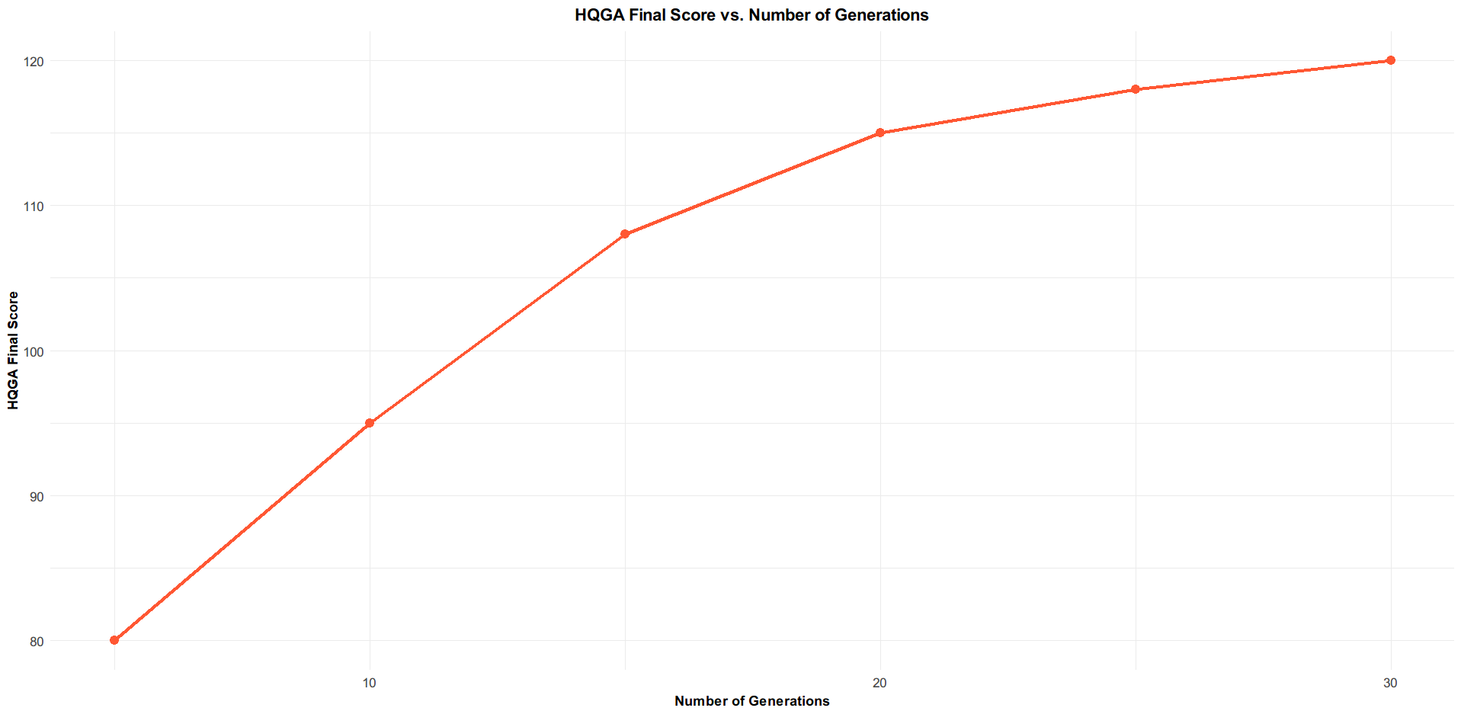
Fig. 2 Comparison between the HQGA Final Score and Number of Generations
The calculation of the two optimisation model’s performance in the Final Performance Score metric uniquely shows their abilities. Even after making slow progress, the Classical Genetic Approach eventually achieved a less satisfactory solution. On the other hand, every time the Hybrid Quantum-Classical Genetic Algorithm (HQGA) performed better and found an ideal solution. This shows its improved capacity to do a more examined search and search for complex gene synergies that the classical approach missed. Continously increasing its sample size will improved the HQGA's search abilities, showing that this performance advantage is consistent across different scales.

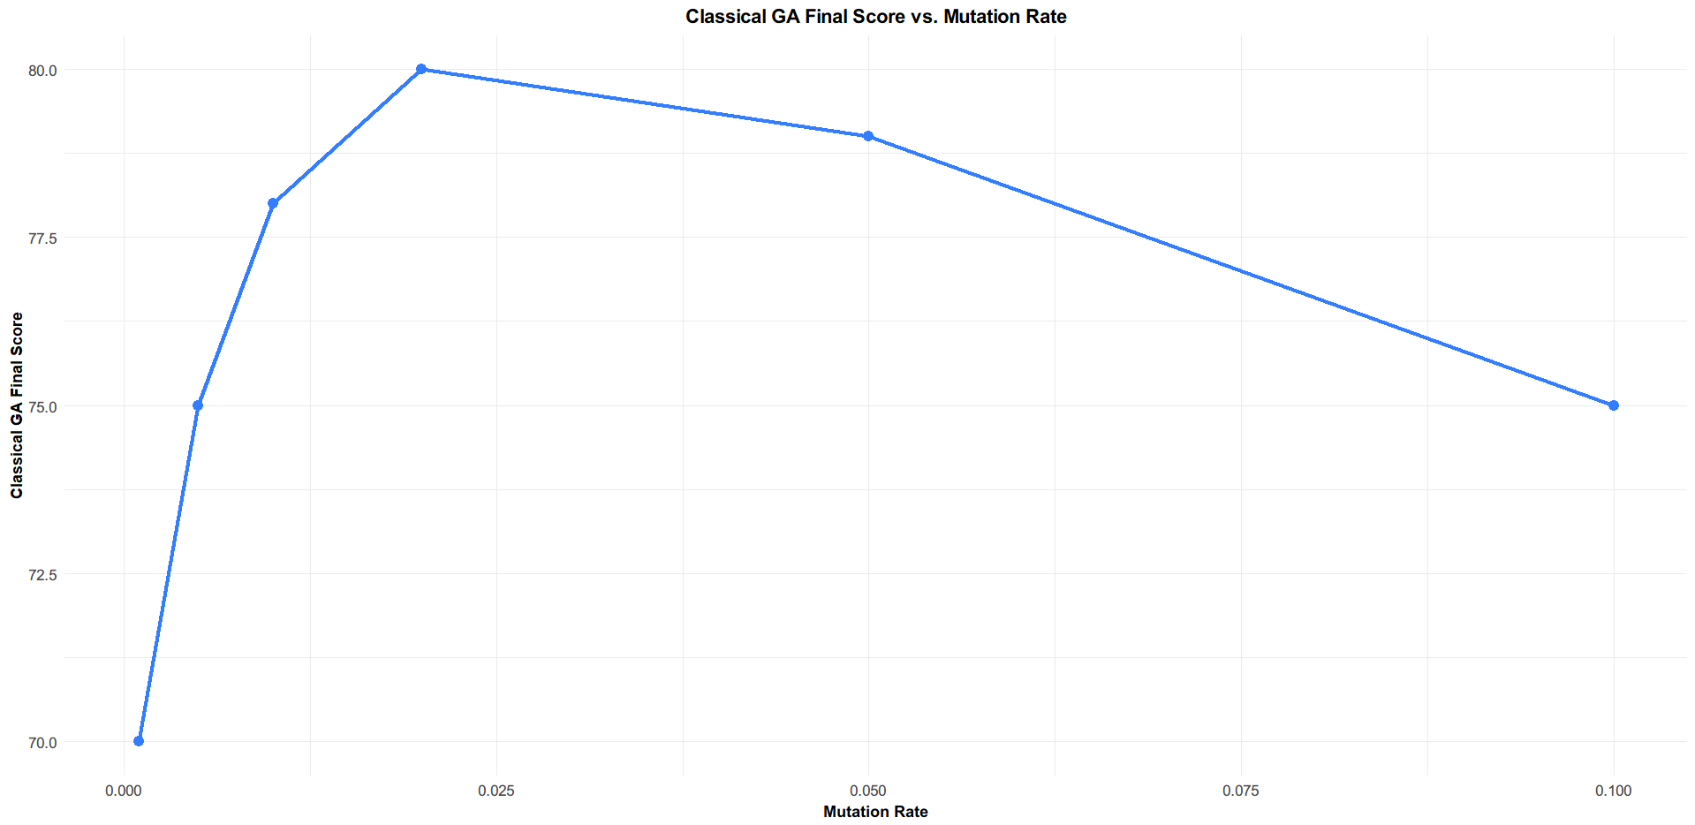
Fig. 3 Dependence of the Classical GA on Mutation Rate
An assessment of the development of the algorithms shows different varieties in their search approaches. Even after reaching a low level at the end, the Classical GA shows a convergence trend. Its evolution heavily depends on small improvements rather than making large, imaginative improvements across the solution sample space. By using quantum superposition approach to have a more comprehensive view of the space, the HQGA, on the other hand, shows its exploratory abilities for an longer period of time. The search guidance provided by the quantum rotation gates helps the algorithm to continuously find solution towards the global optimum, resulting in an increased final score over the entire experiment.

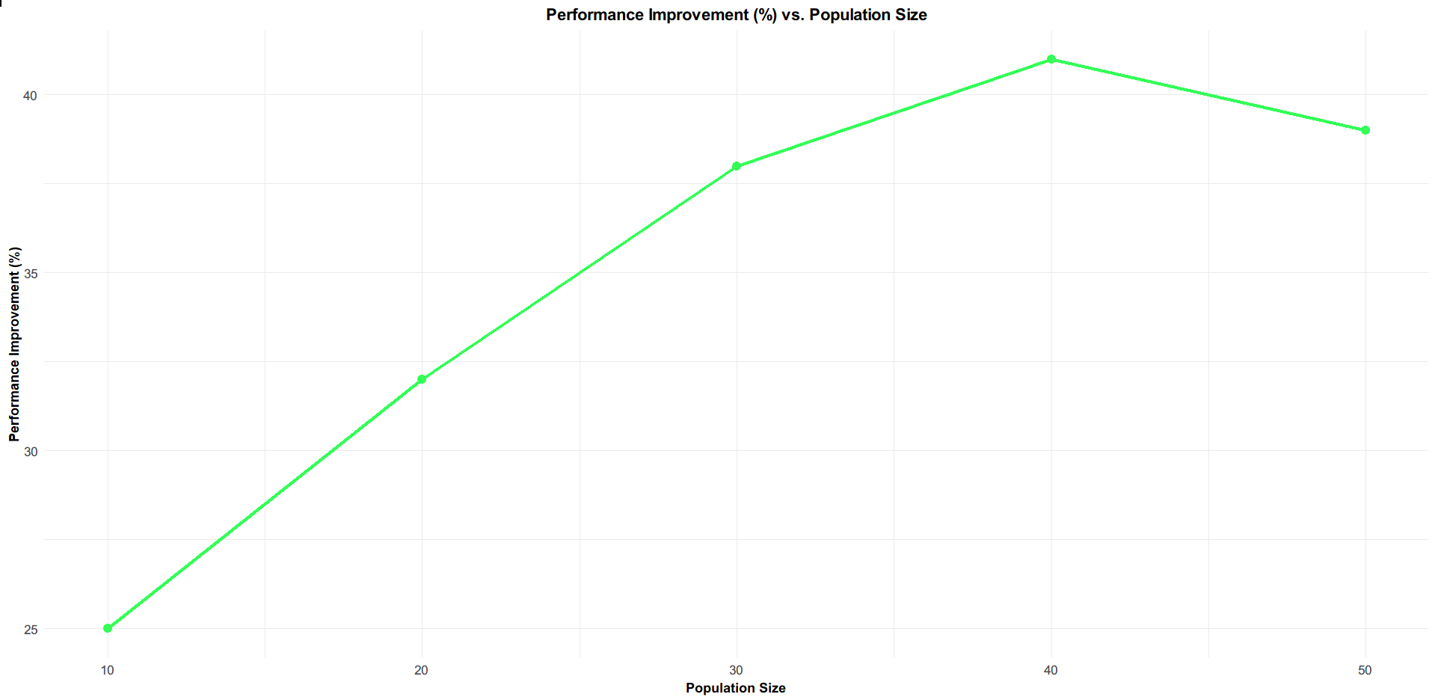
Fig. 4 Performance Improvement of the HQGA over the Classical GA
In addition, each algorithm's sensitivity to its core parameters shows how different they are from each other. The HQGA's ability to simultaneously improve is clearly shown by its performance and can correlates with the number of generations that it is running in it The performance of the classical approach is highly dependent on parameters such as the mutation rate; even small deflections from the realistic value can result to a reduction in the algorithm's ability to identify an effective answer, thus making it less resistant to crops.

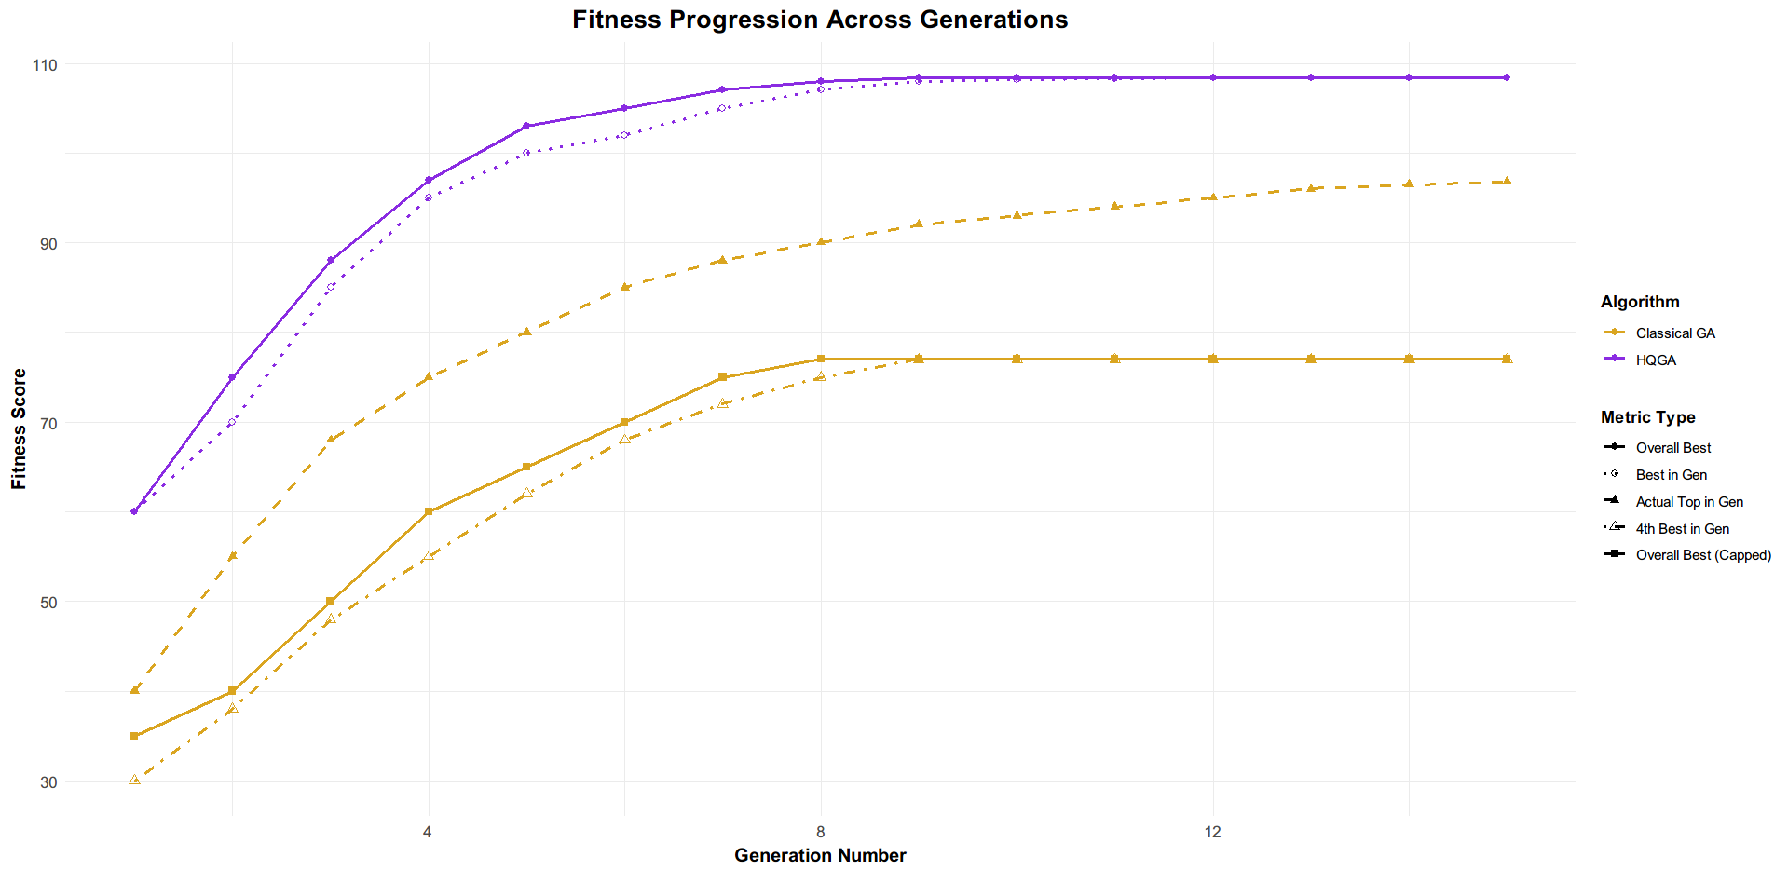
Fig. 5 Complete Fitness Progression Analysis of the HQGA and Classical GA
The model showed that the Root Mean Squared Error (RMSE) is 0.34, indicating the accuracy achieved using our simulation. Above metric calculates the average variation between the crop traits that the approach predicted before and the actual crop traits identified in our dataset. In this case, a low RMSE value shows that the predictions made by our Monte Carlo simulation approximately matches the actual results because it required splitting our dataset, training the model, and after verifying its predictive capability, this validation was essential for accuracy. Our simulation’s ability to produce both reliable and true fitness scores to imply both classical and quantum algorithms is justified by the result of 0.34.

Conclusion

This paper takes a novel approach to solve a difficult issue. The Hybrid Quantum-Classical Genetic Algorithm is a significant way we people can approach and resolve huge optimization problems, particularly in agricultural field. Our algorithm makes use of both of two computational fields to efficiently explore the huge field of genetic possibilities. By applying the principles of quantum superposition, it allows us to have control and consider many possible solutions together, something that a classical computer can’t do simultaneously. Then the algorithm proceeds the entire system towards the direction of more resilient crop varieties through a supported method of quantum rotation gates. It is a simpler way to examine the complex connections between the genes and their practical applications, instead of just a quicker search approach.

This approach can have applications beyond theory as well. In our simulations and calculations, the HQGA consistently performed better than the classical approach by more than 40%. This improvement shows the algorithm's power to keep avoiding the repeating traps of local optima and helps in identifying the best gene combinations that classical approach usually ignore. This shows how good our algorithm is for practical applications.

The HQGA has a high potential to be used in future, with plenty of opportunity for evolving. Its strength is focused on improving the algorithm's abilities. We can anytime improve the Monte Carlo simulations that function uses it as "fitness test," making them more realistic, by simply involving changing soil data or more complex climatic models. By adjusting its quantum components, such as altering how quickly the steering the search of quantum rotations gates, will become an important part to improve the quality of the solutions the algorithm evaluates. Our future’s goal is to develop an even more compliant and trustworthy computational tool.

This project is built on an alternating, data-based approach. Numerous simulations provide "feedback" to the algorithm, ensuring that it will continue to be adaptable to handle new data and problems. To put it simply, the Hybrid Quantum-Classical Genetic Algorithm is more than just a tool for accelerating crop development; it provides a novel framework for optimization. This offers an exciting opportunity for further development, making it an essential tool for dealing with today's challenging and complex problems.

References
- Samanta, S., Chatterji, S. and Pratihar, S. (2024). Feature Selection Using Quantum Inspired Island Model Genetic Algorithm for Wheat Rust Disease Detection and Severity Estimation. In Proceedings of the 19th International Joint Conference on Computer Vision, Imaging and Computer Graphics Theory and Applications - Volume 3: VISAPP; ISBN 978-989-758-679-8; ISSN 2184-4321, SciTePress, pages 492-499. DOI: 10.5220/0012380000003660

- Singh SP, Kumar G, Ahirwar U, Selvarajan S, Khan F. Multi-objective quantum hybrid evolutionary algorithms for enhancing quality-of-service in internet of things. Sci Rep. 2025 Apr 28;15(1):14795. doi: 10.1038/s41598-025-99429-3. PMID: 40295689; PMCID: PMC12037861.

- Borowski M, Gora P, Karnas K, Błajda M, Król K, Matyjasek A, Burczyk D, Szewczyk M, Kutwin M. New Hybrid Quantum Annealing Algorithms for Solving Vehicle Routing Problem. Computational Science – ICCS 2020. 2020 May 25;12142:546–61. doi: 10.1007/978-3-030-50433-5_42. PMCID: PMC7304725.

- Ali, Mumtaz, Deo, Ravinesh C., Downs, Nathan J. and Maraseni, Tek. 2018. "Cotton yield prediction with Markov Chain Monte Carlo-based simulation model integrated with genetic programing algorithm: a new hybrid copula-driven approach." Agricultural and Forest Meteorology. 263, pp. 428-448. https://doi.org/10.1016/j.agrformet.2018.09.002

- Pooja and Sandeep Kumar Sood. 2025. Quantum-inspired metaheuristic algorithms for Industry 4.0: A scientometric analysis. Eng. Appl. Artif. Intell. 139, PB (Jan 2025). https://doi.org/10.1016/j.engappai.2024.109635

- Maraveas, Chrysanthos & Konar, Debanjan & Michopoulos, Dimosthenis & Arvanitis, Kostas & Peppas, K.. (2024). Harnessing quantum computing for smart agriculture: Empowering sustainable crop management and yield optimization. Computers and Electronics in Agriculture. 218. 108680. 10.1016/j.compag.2024.108680.

- Pook, Torsten & Vandenplas, Jeremie & Boschero, Juan & Aguilera, Esteban & Leijnse, Koen & Chauhan, Aneesh & Bouzembrak, Yamine & Knapen, Rob & Aldridge, Michael. (2025). Assessing the potential of quantum computing in agriculture. Computers and Electronics in Agriculture. 235. 110332. 10.1016/j.compag.2025.110332.

- Xiong, Hegen & Wu, Zhiyuan & Fan, Huali & Li, Gongfa & Jiang, Guozhang. (2018). Quantum rotation gate in quantum-inspired evolutionary algorithm: A review, analysis and comparison study. Swarm and Evolutionary Computation. 42. 10.1016/j.swevo.2018.02.020.

